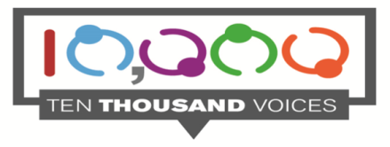
DEVELOPING EYECARE PARTNERSHIPS

Please describe your experience of eye care services, whether as a patient, family member or as a carer.
Your experience can be about any aspect of eye care services, anywhere in Northern Ireland. We are interested in hearing about your overall experience and how this made you feel.
Please note that by taking part in this service user experience survey you are consenting to your anonymous information being used in a variety of ways for example: in the development of reports, staff induction, staff education and training and for meetings, to improve the safety and quality of services and to influence how services are shaped for the future.
I consent to my anonymous information being used as described above: YES/NO
Tell the story of your experience of eyecare services (please feel free to add an additional page)

What is important to you?

What could be improved?

Which clinic did you attend? (Please Tick)
Macular service
Diabetic eye service
Glaucoma service
General ophthalmology outpatient
In patient or day case surgery
POPCC (Paediatric Ophthalmology Priority Consultation Clinic)
Low vision clinic
ECLO (Eyecare Liaison Officer)
Eye Casualty
Other (please specify)

Where was the clinic located?

What are the first 4 digits in your postcode (e.g BT66)

Which Trust does your experience relate to?

Belfast Health and Social Care Trust (BHSCT): Greater Belfast Area

Northern Health and Social Care Trust (NHSCT): Coleraine, Ballymena,Antrim,Carrickfergus, Magherafelt, Cookstown

South Eastern Health and Social Care Trust (SEHSCT): Dundonald, Newtownards, Bangor, Ards peninsula,Lisburn, Ballynahinch, Newcastle

Southern Health and Social Care Trust (SHSCT): Dungannon, Armagh, Newry, Craigavon, Banbridge

Western Health and Social Care Trust (WHSCT): Enniskillen, Omagh, Strabane, Londonderry, Limavady

